Jaw Crusher
Jaw Crusher 1
Jaw Crusher Introduction 1
Jaw Crusher Features and Benefits 1
Jaw Crusher View 1
Jaw Crusher Working Principle 1

Jaw Crusher

Jaw Crusher Introduction
This series of jaw crusher can reach the crushing ratio of 4-6 and the shape of final product is even. They are widely applied to crush high hardness, mid hardness and soft rocks and ores such as slags, construction materials, marble, etc. The pressure resistance strength is under 200Mpa, suitable for primary crush. Jaw Crusher can be used in mining, metallurgical industry, construction, road and railway building, conversancy, chemistry, etc.

Jaw Crusher Features and Benefits
1) Simple structure, easy maintenance
2) Stable performance
3) Flexible capacity
4) Over loading protection
5) Stable performance
6) Stable performance
7) Even final particles and high crushing ratio
8) High efficiency and low operation cost
9) Alternative ordinary and hydraulic types

Jaw Crusher View
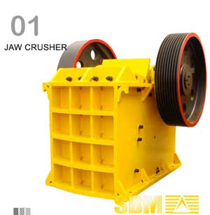

Jaw Crusher Working Principle
This jaw crusher uses motor as its power. Through the motor's wheels, the eccentric shaft is driven by the triangle belt and slot wheel to make the movable jaw plate move by a regulated track. Therefore, the materials in the crushing cavity composed of fixed jaw plate, movable jaw plate and side-lee board can be crushed and discharged through the discharging opening.

More:
- Used jaw crusher
- SBM crusher malaysia
- Stone crusher

